GOAL

1. **Strengthen individual, family and community health, safety and well-being** through effective safety-net services; innovative programming; prevention and early intervention; and environmental stewardship.

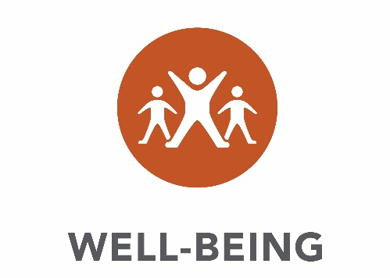

|  |  |  |  |  |  |  |  |  |
| --- | --- | --- | --- | --- | --- | --- | --- | --- |
|  | Part I Crimes  (per 100,000) | | Low Birthweight | | Recycling rate | | Adults report inadequate social-emotional support | |
| 2013  Actual | 2014  Actual | 2013  Actual | 2014  Actual | 2013  Actual | 2014  Actual | 2013  Actual | 2014  Actual |
| Ramsey County | 3,923 | 3,738 | 7.3% | 7.3% | 50.4% | 52.5% | 14.3% | 14.3% |
| 7-County Metro | 3,108 | 2,972 | 6.5% | 6.5% | 47.7% | N/A | 13.1% | 13.1% |

**GOAL**

1. **Cultivate economic prosperity and invest in neighborhoods with concentrated financial poverty** through proactive leadership and inclusive initiatives that engage all communities in decisions about our future.



|  |  |  |  |  |  |  |  |  |
| --- | --- | --- | --- | --- | --- | --- | --- | --- |
|  | Employment Growth from previous year | | Gap between Median Household Income and Median Cost of Living | | Percent of Full-Time Workers living Below Poverty Level | | Percent of Residents living in areas of concentrated financial poverty | |
| 2013  Actual | 2014  Actual | 2013  Actual | 2014  Actual | 2013  Actual | 2014  Actual | 2013  Actual | 2014  Actual |
| Ramsey County | 0.7% | 1.0% | N/A | - 3% | 2.3% | 2.5% | 32.4% | 29.9% |
| 7-County Metro | 1.9% | 1.5% | N/A | 18% | 1.3% | 1.4% | 14.5% | 13.8% |

**GOAL**

1. **Enhance access to opportunity and mobility for all residents and businesses** through connections to education, employment and economic development throughout our region.



|  |  |  |  |  |  |  |  |  |
| --- | --- | --- | --- | --- | --- | --- | --- | --- |
|  | Percent of population  25 to 34 years old | | Percent of commuters who can commute to work in less than 30 minutes | | Percent of Highway miles rated in “poor” condition | | Poverty rate for People of Color | |
| 2013  Actual | 2014  Actual | 2013  Actual | 2014  Actual | 2013  Actual | 2014  Actual | 2013  Actual | 2014  Actual |
| Ramsey County | 16% | 16% | 71% | 70% | 8.8% | 10.5% | 28.9% | 30.7% |
| 7-County Metro | 15% | 15% | 67% | 66% | 4.3% | 4.4% | 20.9% | 21.4% |

**GOAL**

**4. Model forward-thinking investment, fiscal accountability and transparency** through professional operational and financial management.



|  |  |  |  |  |  |  |  |  |
| --- | --- | --- | --- | --- | --- | --- | --- | --- |
|  | **Voter turnout as a percentage of eligible voters** | | **Moody’s Aaa**  **Standard & Poor’s AAA Bond Ratings** | | **Assessment Ratio** | | **Net Bonded Debt Per Capita** | |
| 2008  Actual | 2012  Actual | 2013  Actual | 2014  Actual | 2013  Actual | 2014  Actual | 2013  Actual | 2014  Actual |
| **Ramsey County** | 71.9% | 69.8% | **√** | **√** | 93.8 | 96.5 | $370 | $357 |
| **7-County Metro** | 76.0% | 75.3% | N/A | 3 | 94.0 | 95.8 | $309 | $394 |